Demand Forecasting Notebook Analysis Report
Date: 2026-05-16
Source: Demand Forecasting.ipynb

Notebook Summary
Total cells: 129
Markdown cells: 59
Code cells: 70
Extracted result images from saved outputs: 37

Project Objective
This notebook performs end-to-end demand forecasting analysis for Walmart weekly sales. It includes exploratory data analysis, feature engineering, outlier handling, and multiple forecasting models (XGBoost, SARIMA, LSTM, and Prophet), followed by model comparison.

What Was Analyzed
- Data loading and integration across train, stores, and features datasets.
- Temporal analysis of weekly sales trends, including holiday-season spikes.
- Store-type and macro-feature analysis (temperature, fuel price, CPI, unemployment).
- Outlier review and filtering strategy for robust supervised learning.
- Feature engineering for calendar and seasonal effects.
- Training and evaluation of XGBoost, SARIMA, LSTM, and Prophet models.

Key Findings (from notebook narrative and outputs)
- Sales spikes are concentrated in Q4, especially around Thanksgiving/Black Friday/Christmas.
- Store type and seasonal calendar effects are more informative than macro variables for direct weekly sales movement.
- Outlier removal affects a very small share of rows and improves modeling stability.
- XGBoost is reported in the notebook as the strongest performer among tested methods.
- SARIMA captures aggregate trend/seasonality but underperforms multivariate ML methods for this dataset.
- LSTM and Prophet sections extend forecasting to nonlinear and decomposable time-series perspectives.

Result Visuals Extracted from Notebook
Cell 20: Stores Data
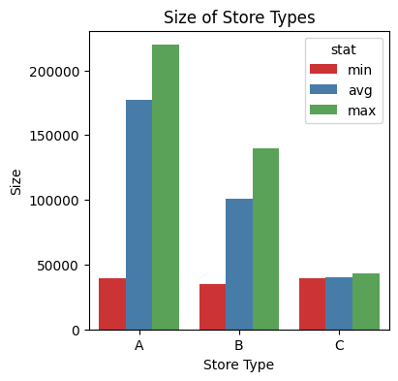
Cell 23: Sales Data
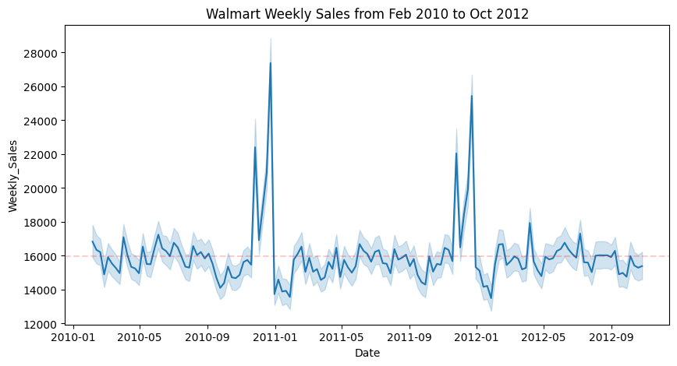
Cell 26: Taking a closer look at the Spike
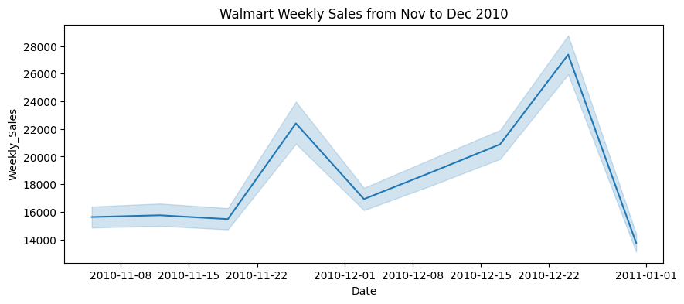
Cell 30: Analyzing Sales by Month, Quarter, Year
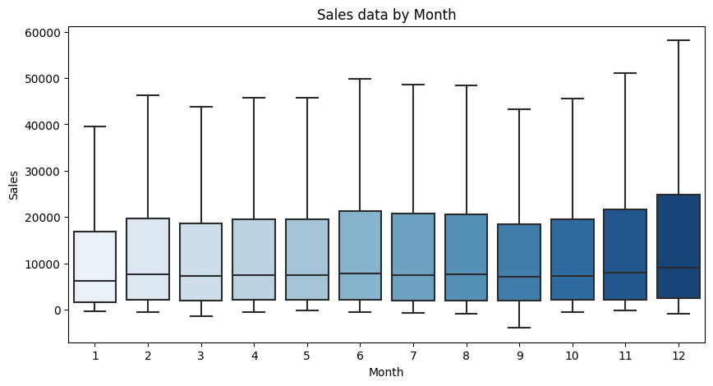
Cell 32: - We can see the increase in sales in Nov(11) and December(12)
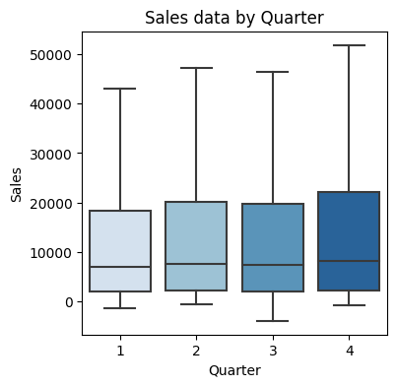
Cell 34: **Q4 has the highest sales due to holiday season**
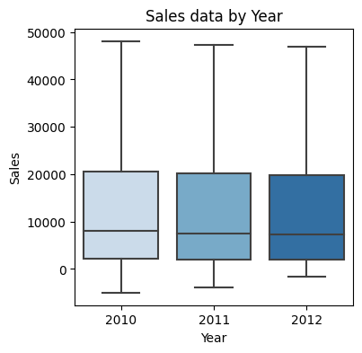
Cell 36: **We see a decrease in Sales from 2010 to 2012, It can happen due to the following reasons:**
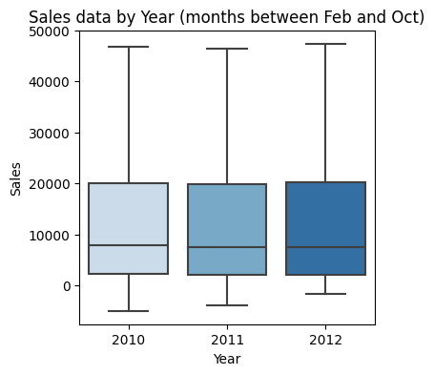
Cell 38: **Taking data of Months Feb-Oct as they are available for all years**
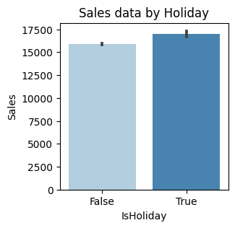
Cell 41: Analyzing Store Types with Sales
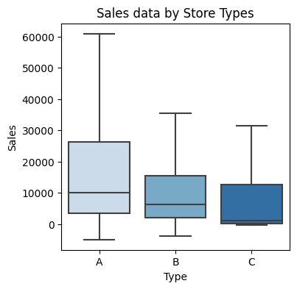
Cell 42: Analyzing Store Types with Sales
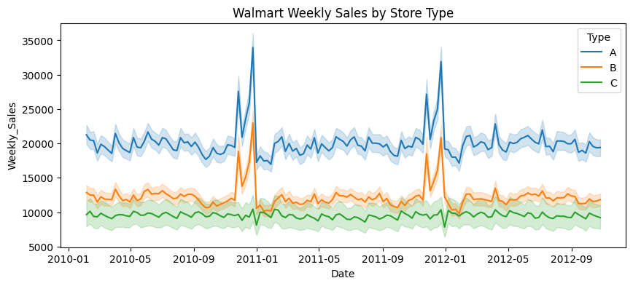
Cell 45: Analyzing additional Features with Sales
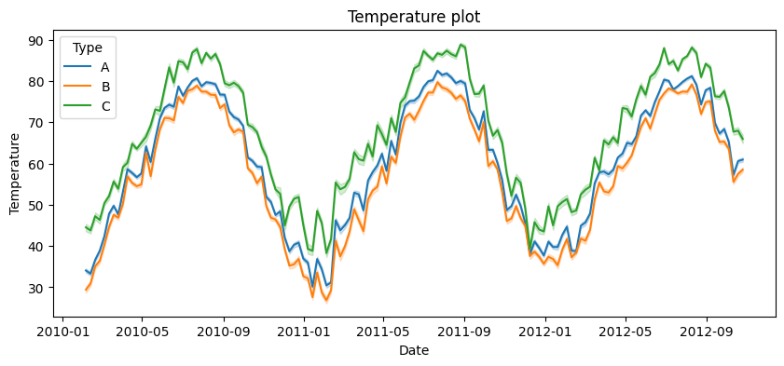
Cell 47: - Temperature around Type C stores (small stores) is high compared to other stores
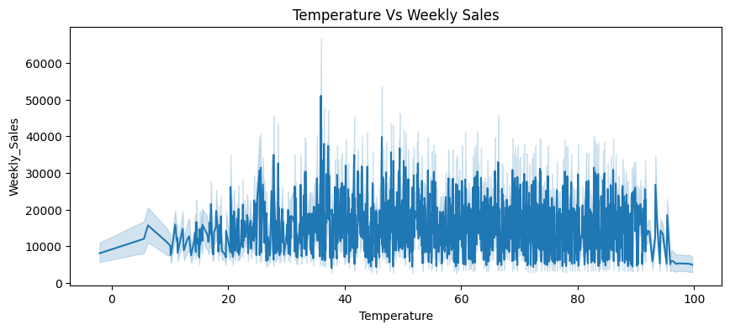

Portfolio Positioning
This project demonstrates practical demand forecasting capability across the full analytics lifecycle: data preparation, EDA, feature engineering, model development, and comparative evaluation. For portfolio presentation, it showcases both classical time-series methods and modern ML/deep-learning approaches.

Files
#file:Demand Forecasting.ipynb

